**top command:**

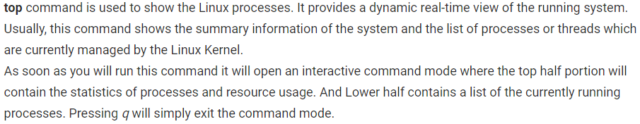

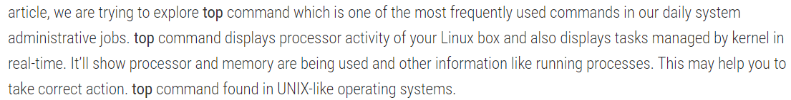

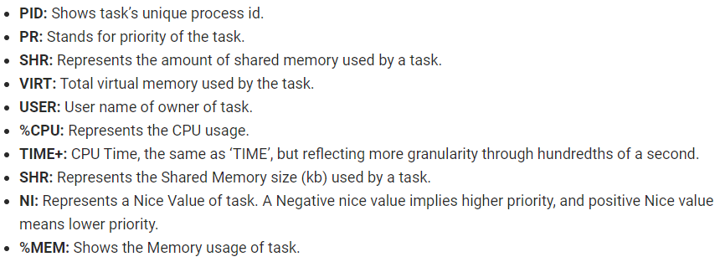

Top output keep refreshing until you press **‘q‘**. With below command top command will automatically exit after 10 number of repetitions.

* **top -n 10**

Display Specific User Process

* **top -u paras**

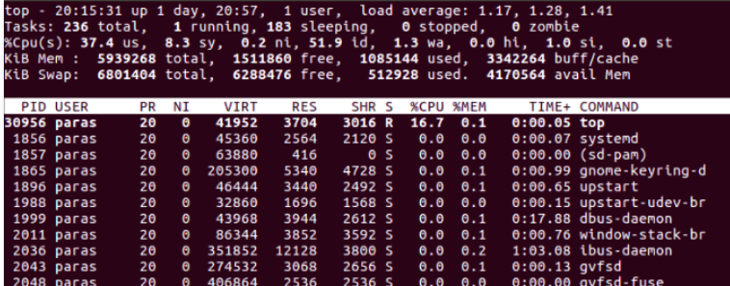

Press **‘z‘option** in running top command will display running process in colour which may help you to identified running process easily

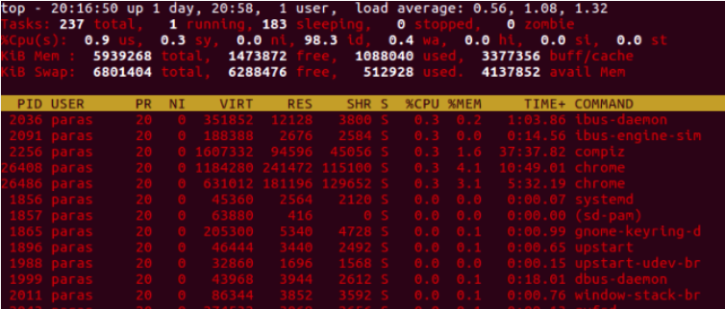

Press **‘c‘option** in running top command, it will display absolute path of running pro

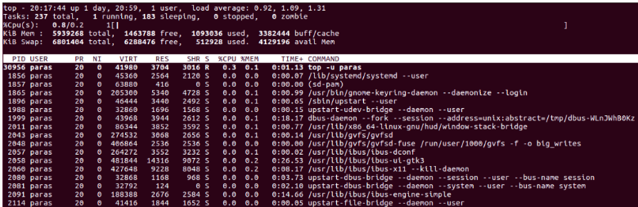

* You can kill a process after finding PID of process by pressing **‘k‘option** in running top command without exiting from top window
* Press **(Shift+P)** to sort processes as per CPU utilization.

Send output from top to file or any other programs.

* **top -b**

Use top in Secure mode.

* **top -s**

The below command starts top with last closed state.

* **top -c**

By default screen refresh interval is 3.0 seconds, same can be change pressing **‘d‘option** in running top command and change it as desired as shown below.

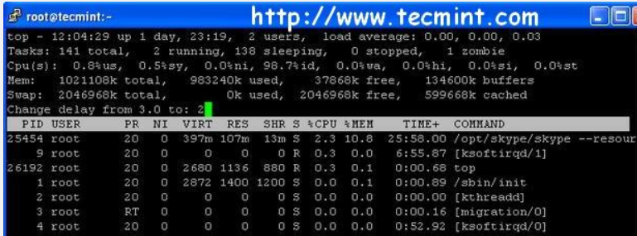

**htop command:**

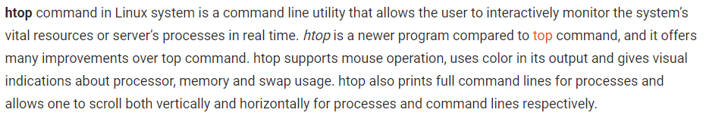

**Options:**

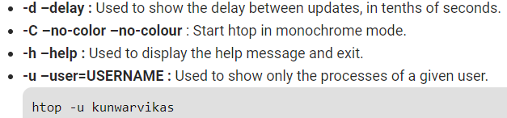

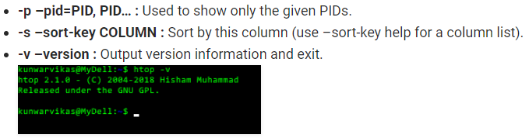

**Interactive commands:**

